



**Scaling Digital Twin Experiences 202  
Configurations with the Identity Resolution Service**

**Copyright © 2020 PTC Inc. and/or Its Subsidiary Companies. All Rights Reserved.**

User and training guides and related documentation from PTC Inc. and its subsidiary companies (collectively "PTC") are subject to the copyright laws of the United States and other countries and are provided under a license agreement that restricts copying, disclosure, and use of such documentation. PTC hereby grants to the licensed software user the right to make copies in printed form of this documentation if provided on software media, but only for internal/personal use and in accordance with the license agreement under which the applicable software is licensed. Any copy made shall include the PTC copyright notice and any other proprietary notice provided by PTC. Training materials may not be copied without the express written consent of PTC. This documentation may not be disclosed, transferred, modified, or reduced to any form, including electronic media, or transmitted or made publicly available by any means without the prior written consent of PTC and no authorization is granted to make copies for such purposes. Information described herein is furnished for general information only, is subject to change without notice, and should not be construed as a warranty or commitment by PTC. PTC assumes no responsibility or liability for any errors or inaccuracies that may appear in this document.

The software described in this document is provided under written license agreement, contains valuable trade secrets and proprietary information, and is protected by the copyright laws of the United States and other countries. It may not be copied or distributed in any form or medium, disclosed to third parties, or used in any manner not provided for in the software licenses agreement except with written prior approval from PTC.

UNAUTHORIZED USE OF SOFTWARE OR ITS DOCUMENTATION CAN RESULT IN CIVIL DAMAGES AND CRIMINAL PROSECUTION.

PTC regards software piracy as the crime it is, and we view offenders accordingly. We do not tolerate the piracy of PTC software products, and we pursue (both civilly and criminally) those who do so using all legal means available, including public and private surveillance resources. As part of these efforts, PTC uses data monitoring and scouring technologies to obtain and transmit data on users of illegal copies of our software. This data collection is not performed on users of legally licensed software from PTC and its authorized distributors. If you are using an illegal copy of our software and do not consent to the collection and transmission of such data (including to the United States), cease using the illegal version, and contact PTC to obtain a legally licensed copy.

**Important Copyright, Trademark, Patent, and Licensing Information:** See the About Box, or copyright notice, of your PTC software.

**UNITED STATES GOVERNMENT RIGHTS**

PTC software products and software documentation are “commercial items” as that term is defined at 48 C.F.

1. 2.101. Pursuant to Federal Acquisition Regulation (FAR) 12.212 (a)-(b) (Computer Software) (MAY 2014) for civilian agencies or the Defense Federal Acquisition Regulation Supplement (DFARS) at 227.7202-1(a) (Policy) and 227.7202-3 (a) (Rights in commercial computer software or commercial computer software documentation) (FEB 2014) for the Department of Defense, PTC software products and software documentation are provided to the U.S. Government under the PTC commercial license agreement. Use, duplication or disclosure by the U.S. Government is subject solely to the terms and conditions set forth in the applicable PTC software license agreement.

PTC Inc., 121 Seaport Blvd, Boston, MA 02210 USA

**Introduction**

The Identity Resolution Service, or IRS, is a key component to how Vuforia Studio works. It is a component of the Experience Service that your Studio experience is connected to that manages mappings used for linking identifiers, like bar codes or ThingMarks, to a certain experience. This is how you can tell unique Studio experiences from one another, enabling digital twin technology to exist.

In its simplest form, the IRS provides a means to map a URN (Uniform Resource Name) to a value. The URN might represent a thingmark. The value might be a reference to an Experience. When you publish an experience from within Studio, a link is made between the thingmark and the experience. See (1) below,left.

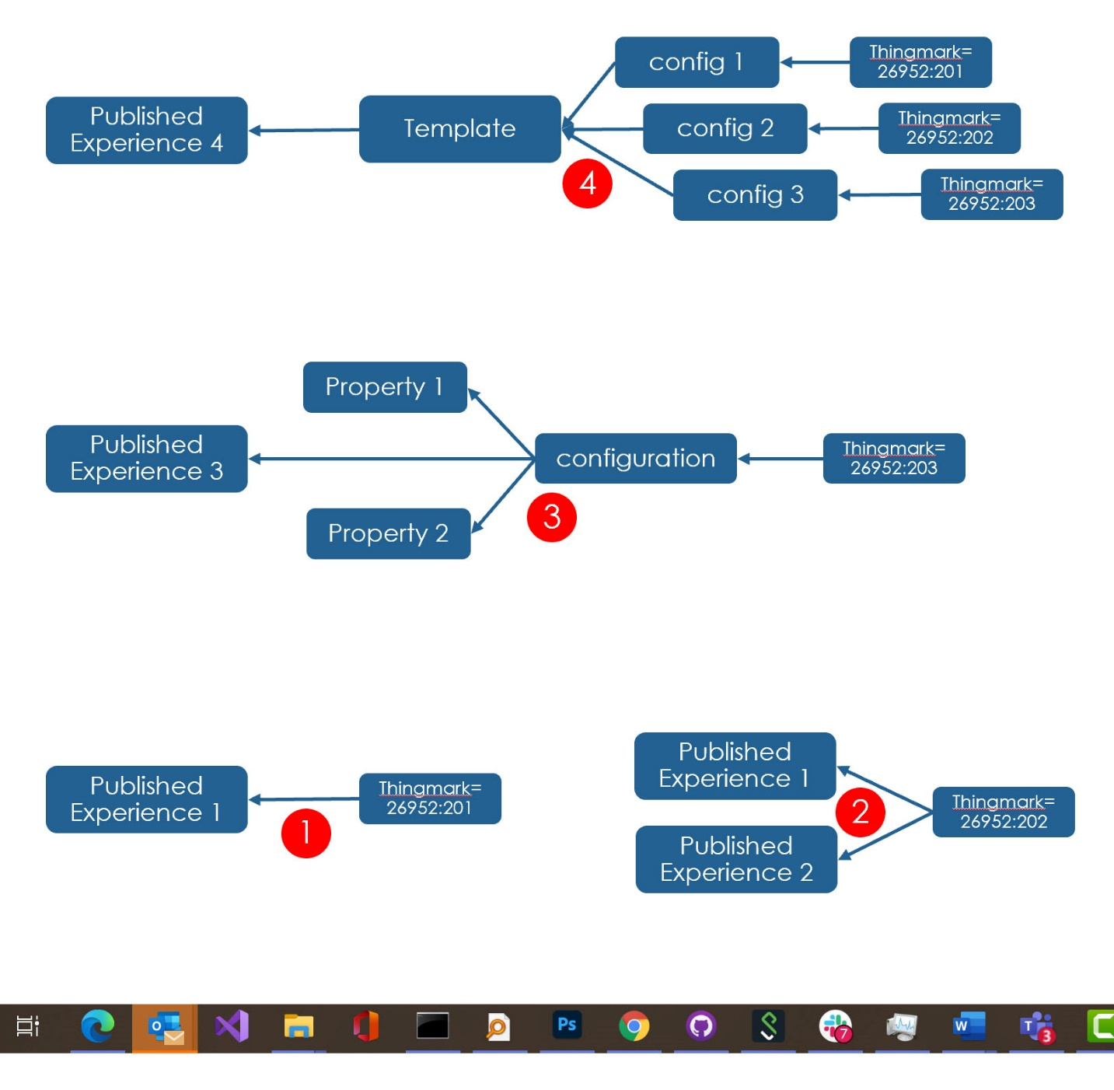

When publishing other experiences, you have the option to use the same or different thingmark. An example of using the same thingmark might be that you have created an Operational AR experience and a Service AR experience. They are different experiences – different content etc., - but they are linked to the same thingmark which is linked to a specific product, perhaps even a specific serial numbered product. This example (2) appears above, right – a single thingmark that links to two experiences. View will ask you which one to run if you scan this thingmark.

The IRS is in fact a very flexible and generic mapping tool, and you can create very rich collections of data. In the example (3) below, we show how a URN (a thingmark in this example) can be mapped to an intermediate item (another URN) which in turn is mapped to the experience but also a couple of property values.



When this thingmark is scanned, the IRS will traverse this structure, collecting all the values along the way. The various URNs that are visited are gathered, and their properties – the ‘value’ - is delivered in the result. In some cases, the value may be used as a parameter e.g. the value being substituted for the name if referenced in the result. In the example above, the property values collected may represent attributes of the model (let’s say the color and price), and these values can be passed into the experience when it is launched.

In the final example below, you see another property of the IRS. The path to the value does not have to be unique e.g. multiple starring URNs (three different thingmarks in this example) can gather different property values along the way, but the all resolve to the same experience (4). Just as above, the final value (the experience) may substitute the various property values that were gathered along the way, such that when the experience launches, it is configured to represent the exact state of the product that is identified by the scanned thingmark. Here we are now on the parth to being able to model our Digital Twin. We can uniquely identify an ‘instance’ of an item (e.g. using a thingmark – you can also use other techniques such as barcodes) and we can manage all the information pertaining to the unique product instance. 

In this series of tutorial, we will demonstrate these concepts, building up to an example of how you might manage a fleet of products (in this case, toy helicopters) where each product maintains its own representation, its own configuration – there are different models with different accessories – and its own identity (here we allow each to manage it’s own color). We will also show how to Thingworx, allowing each physical item to have an IOT presence. Thingworx might also be used to maintain all the operational information related to the model – battery usage, speed of flight etc. We wont show that here, but the interested reader could use this tutorial as a starting point to build out something more comprehensive.

Our experience will take a number of parameters which we will define using property values stored in the IRS – the properties will be the color, the name of the Thing (in Thingworx) that represents this specific item, and finally the name of the visual representation of our model. As the IRS navigates the URN mapping, it will gather these property values, passing them to the template. Here, the name is substituted by the value.

Seral numbered item - 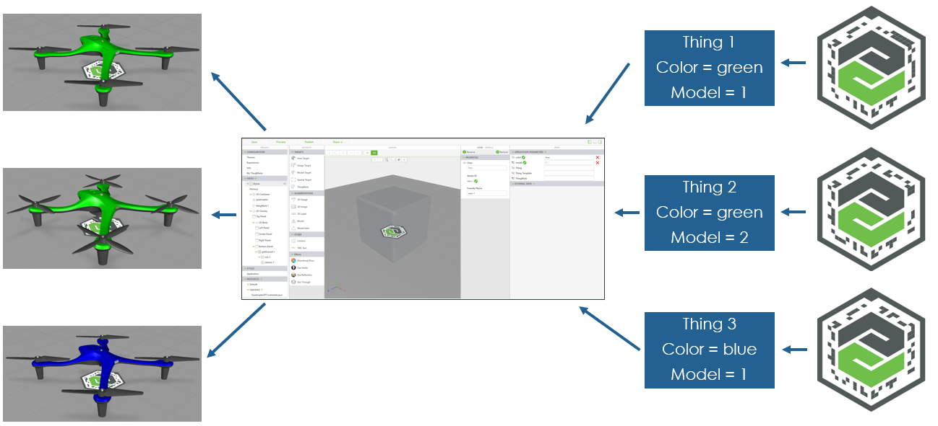

Let’s start by setting up access to the IRS.

**201.1 Download cURL**

You need to use cURL to interact with the IRS. cURL is a command-line tool for getting and sending data using URL syntax. This step is only necessary for Windows users, if you are running macOS then cURL has already been downloaded. To test your cURL installation on macOS, follow [these steps](https://develop.zendesk.com/hc/en-us/articles/360001068567-Installing-and-using-cURL#test).

1. Create a folder to save your cURL download in. For our use, we created a folder named *installations* in our C: drive.
2. Navigate to the [cURL download site](https://curl.se/download.html) and download the cURL version specific for your operating system.
3. Unzip the downloaded folder and find the **curl.exe** and **curl-ca-bundle.crt** files. The version that we downloaded had the files in the **bin** folder.

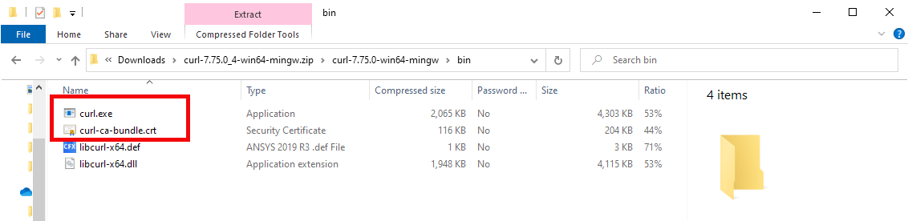

1. Move these files into the *installations* folder that you created.

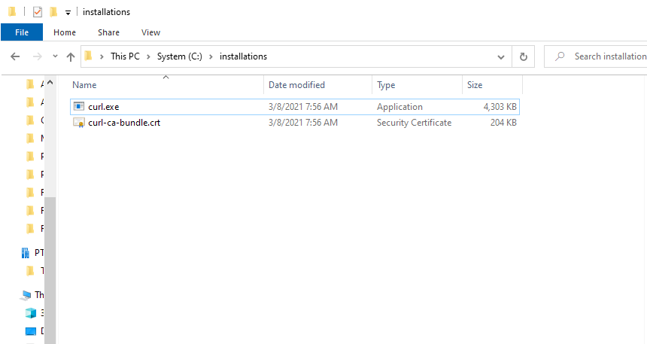

1. The folder path will need to be added to the Windows PATH environment variable so the curl command is available from any location.
   1. In the Start menu of your computer, search for **This PC**, right-click on it, and choose Properties.
   2. Select **Advanced System Settings.**
   3. In the **Advanced** tab, click the **Environment Variables** button at the bottom of the window.
   4. Select the **Path** variable in the **System Variables** list and click **Edit**
   5. In the **Edit environment variable** dialog box, click **New** and add the path to your **curl.exe** file. If you have been following this convention, the new path will be *C:\installations*.

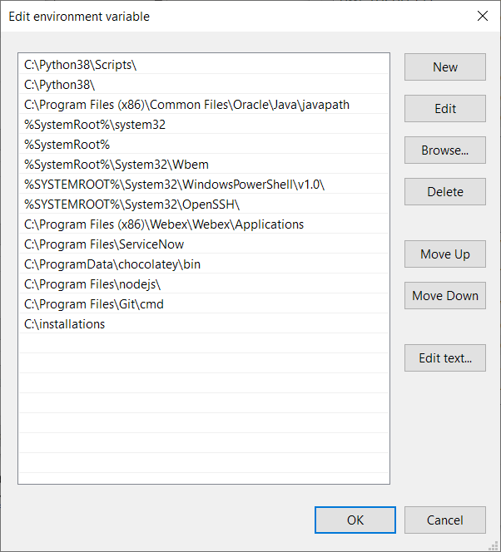

* 1. The path has been successfully added, click **OK** to accept the changes for each of the windows that were opened.

1. cURL has now been installed on your computer.

**201.2 Preparing Vuforia Studio**

Before any mappings with the IRS can be created, your Vuforia Studio experience needs to be set up properly with a ThingMark and published.

1. Open Vuforia Studio.
2. Create a duplicate of the ScalingDigitalTwinExperiences201experience that was created in the last tutorial. Click the **Save As** button in the top-left corner of the Experience Tile. Name the new experience ScalingDigitalTwinExperiences202 and click **Duplicate**.

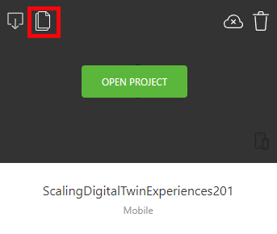

1. A new project named ScalingDigitalTwinExperiences202 appears on your **My Projects** page. Click **Open Project**.
2. The experience should look exactly like ScalingDigitalTwinExperiences201 experience. If so, then the duplication has been completed successfully.

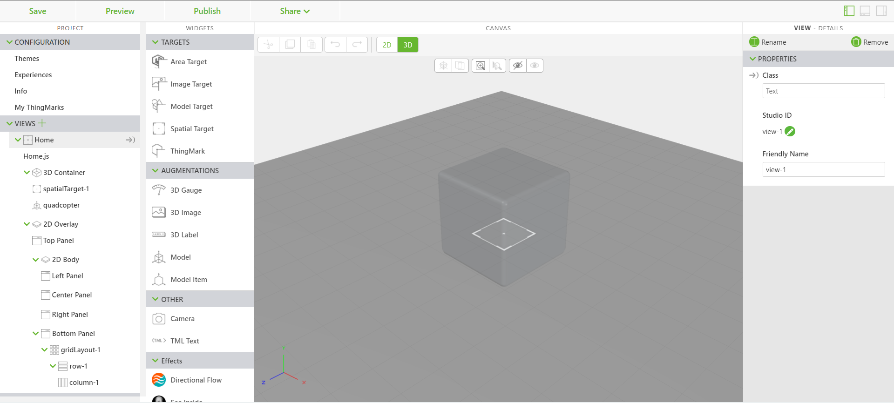

1. Remove the Spatial Target from the experience and replace it with a ThingMark. This is necessary because the experience needs to be mapped to a specific ThingMark.

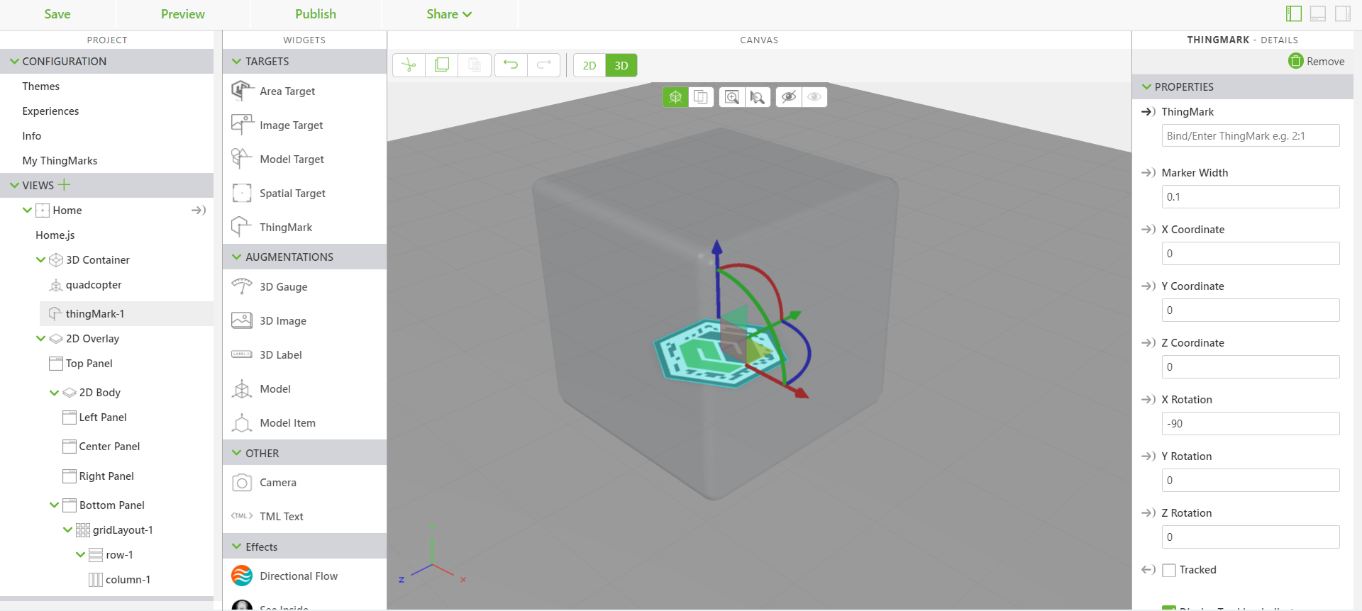

1. In the **Experiences** section under **Configuration**, set the **ThingMark Assocation** dropdown to **ThingMarks**. Then assign the experience to one of your ThingMarks that are associated with your Experience Service.

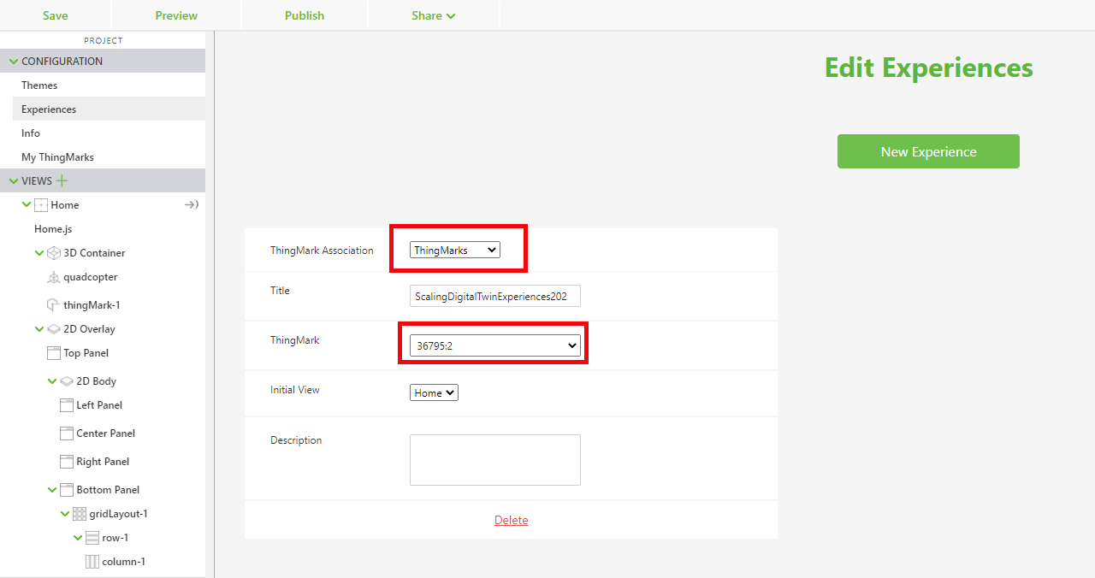

1. **Publish** your experience. This is a necessary step, as it gets the unconfigured version of your experience into the IRS.
2. A completed template for this version of the Studio experience can be found in [GitHub](https://github.com/PTCInc/StudioExamples/tree/master/Scaling%20Digital%20Twin%20Experiences/Scaling%20Digital%20Twin%20Experiences%20200/ScalingDigitalTwinExperiences202).

**202.3** **Mapping with the IRS**

The IRS allows you to create configurations in a way that is scalable for multiple configurations of a model template that maps to an experience. These mappings will be created by using cURL to connect your command line interface (CLI) with your Experience Service. This section will walk you through the step-by-step process of mapping your experience.

1. Ensure that your experience has been published inside Vuforia Studio and has a ThingMark associated with it.
2. If you haven’t already, download the following .bat files listed in [GitHub](https://github.com/PTCInc/StudioExamples/tree/master/Scaling%20Digital%20Twin%20Experiences/Scaling%20Digital%20Twin%20Experiences%20200): mappings.bat, resolve.bat and add them to the same folder where you stored **curl.exe**.
3. Open your CLI of choice. We used Command Prompt for this tutorial.

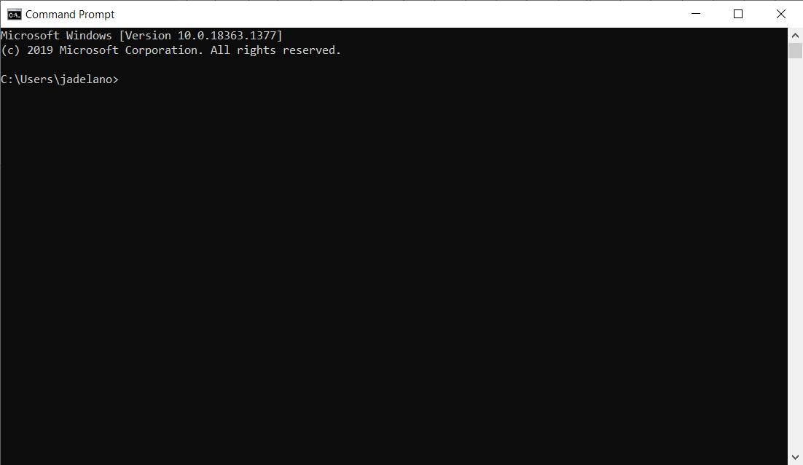

1. Navigate to the directory that you saved your **curl.exe** file in earlier. Ours was saved in **C:\installations**.

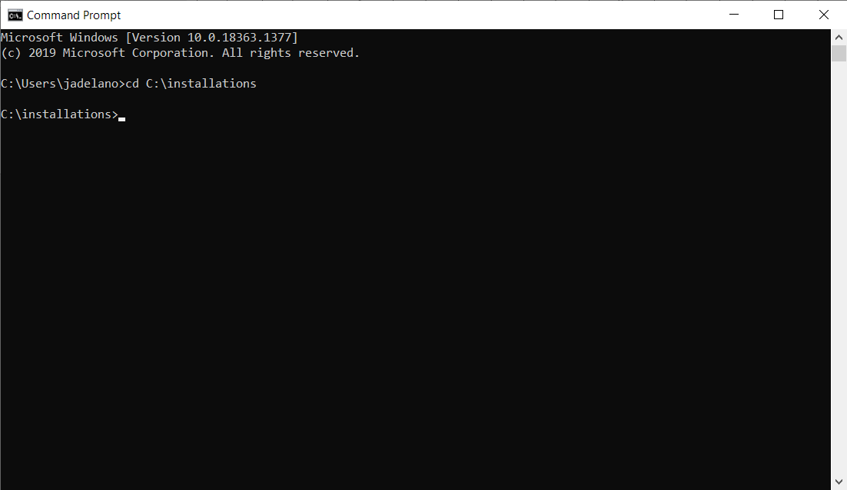

1. In the CLI, type mappings. This will run the mappings.bat file that you downloaded, which sets the login credentials for your username, password, and Experience Server. It then uses cURL to access your Experience Service and find all the experiences that are associated with the Experience Service. You should see all the experiences that you have published so far in the list. Our password has been hidden for security.

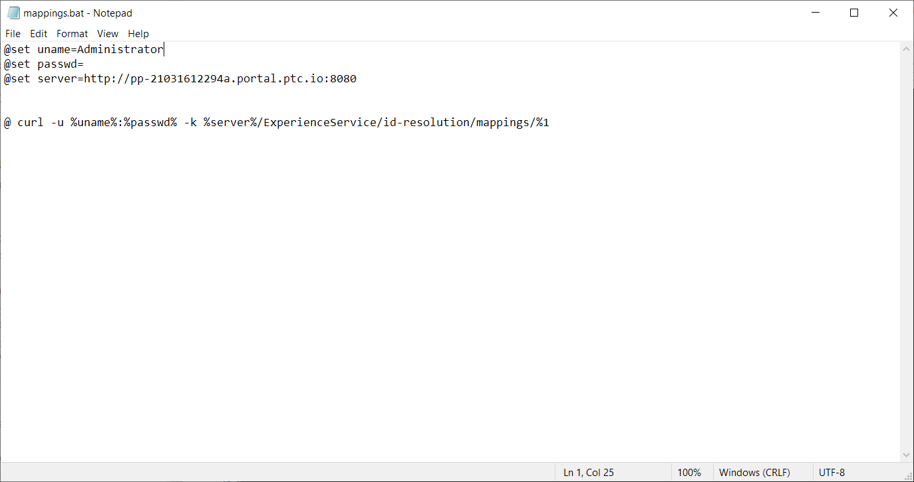

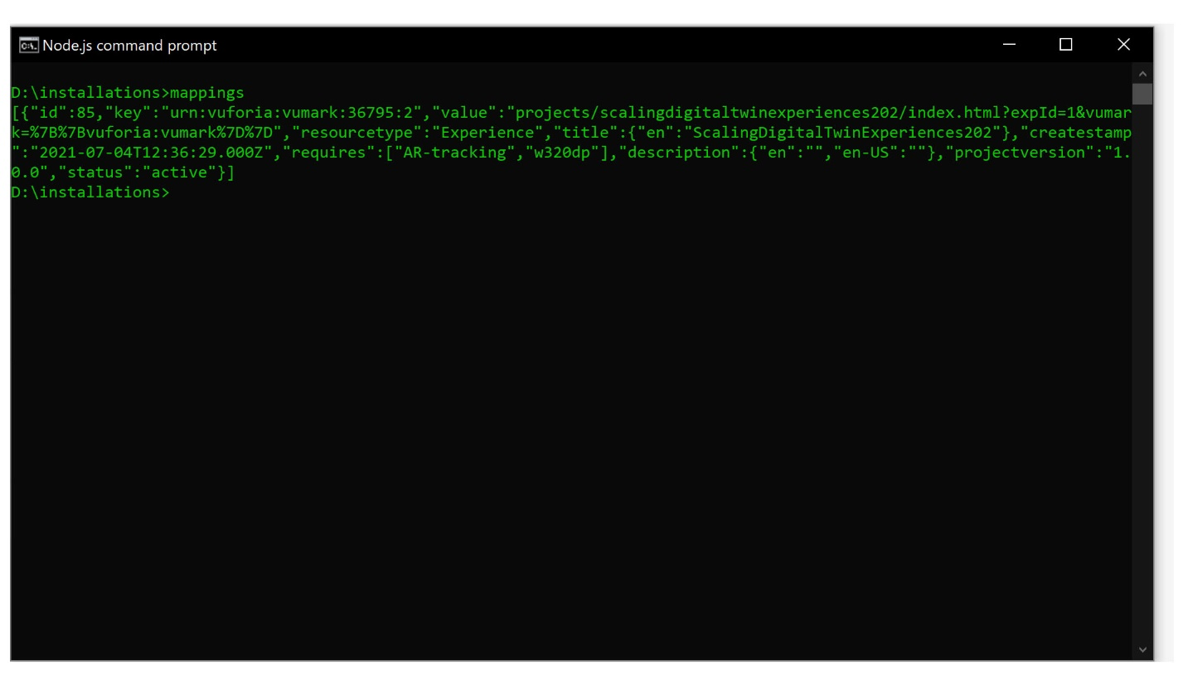

1. Next, you will set the results of running mappings to their own batch file so you can edit the properties that were created when publishing from Studio. Use the command mappings > mymap.bat to create a new batch file. This new file will be placed into your current directory and be used to create a template for the experience that can be configured.

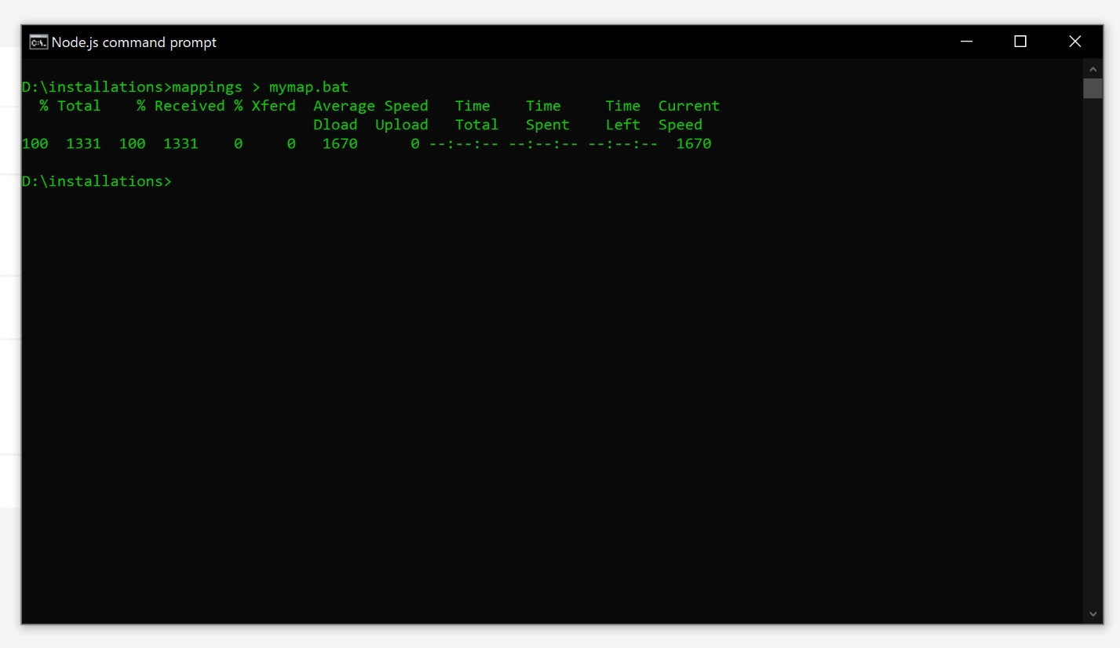

1. Open your newly created mymap.bat file. You will see the results from mapping your experiences. Find the project that you just created, it will most likely be at the end of the file. You will be able to find the mapping for the file that you published by looking at the value property of the mappings and seeing which one says projects/scalingdigitaltwinexperiences202/index.html?expId=1&vumark=%7B%7Bvuforia:vumark%7D%7D".

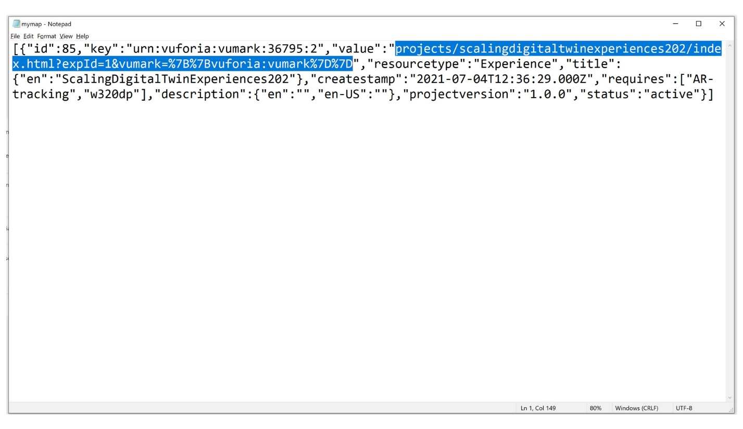

* 1. Each property of the mapping is listed below
     1. id: the ID number for the mapping
     2. key: the ThingMark that you associated the experience with
     3. value: The URL of the experience. It is in the form of path/page.html?parameters. The path/page.html portion is the experience name. The parameters are mapped with their values. In this case, expId is its own parameter that has a value of 1, and vumark is its own parameter with a value of %7B%7Bvuforia:vumark%7D%7D. These parameters will be updated as more configurations are created.
     4. Resourcetype: the type of resource that this is associated with
     5. Title: the title of the experience that you created in the **Info** section of Vuforia Studio
     6. Createstamp: the timestamp for the mapping being created
     7. Requires: sets the tracking requirements
     8. Description: the description of the project if you created one
     9. Projectversion: the version of the project

1. The first step to editing the batch file is to remove parameters from it. Remove the id, createstamp, status and projectversion properties from the file completely. Remove the entire value for the key property and remove everything after projects/myproject/index.html?expId=1 in the value property. (**Note:** We ultimately need to keep this as a single line of text **-** the formatting of the JSON in the .bat file below has been edited for easier readability.)

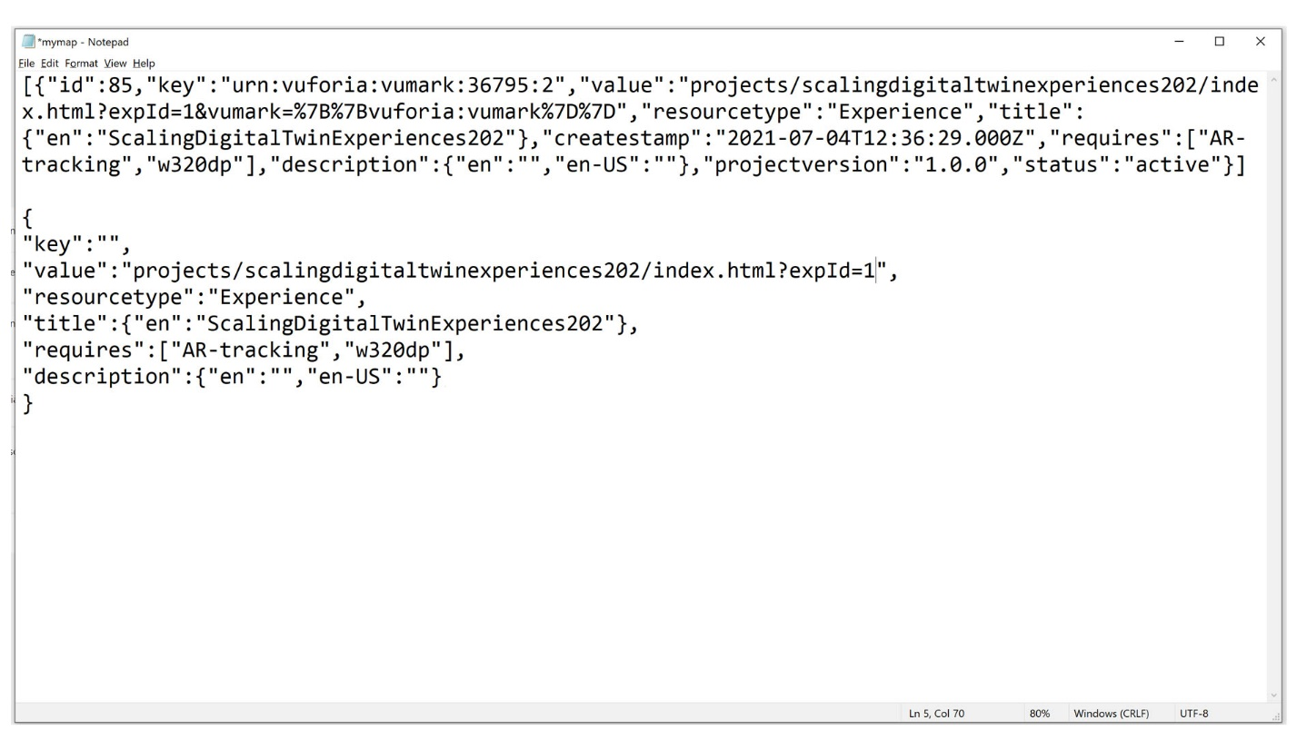

1. Next, you will need to add new parameters to your value property. These parameters will be the same ones that you created in the previous tutorial for the color and the model of the quadcopter model and will be used to configure the experience. curriculum is the name of the template that we are creating, but you can name it something different if you choose. Change the value property to have the following code:

"value":"projects/scalingdigitaltwinexperiences202/index.html?expId=1&color=%7B%7Bcurriculum:color%7D%7D&model=%7B%7Bcurriculum:model%7D%7D",

What is this doing? If we look at this text we’ve just added, we can see this pattern

&color=%7B%7Bcurriculum:color%7D%7D

Which if we break it down, this is a url-encoded query parameter of the form &name=value – in this case, the name is ‘color’ and the value is {{curriculum.color}}. The double braces indicate the value inside is to be evaluated – in this case, we look for the value of (urn.)curriculum.color, which we will see that we will add to the IRS.

1. A key needs to be created for the experience to map to. Add the key below that maps to the template that we are creating named curriculum. This completes your template.

"key":"urn:curriculum:template:202"

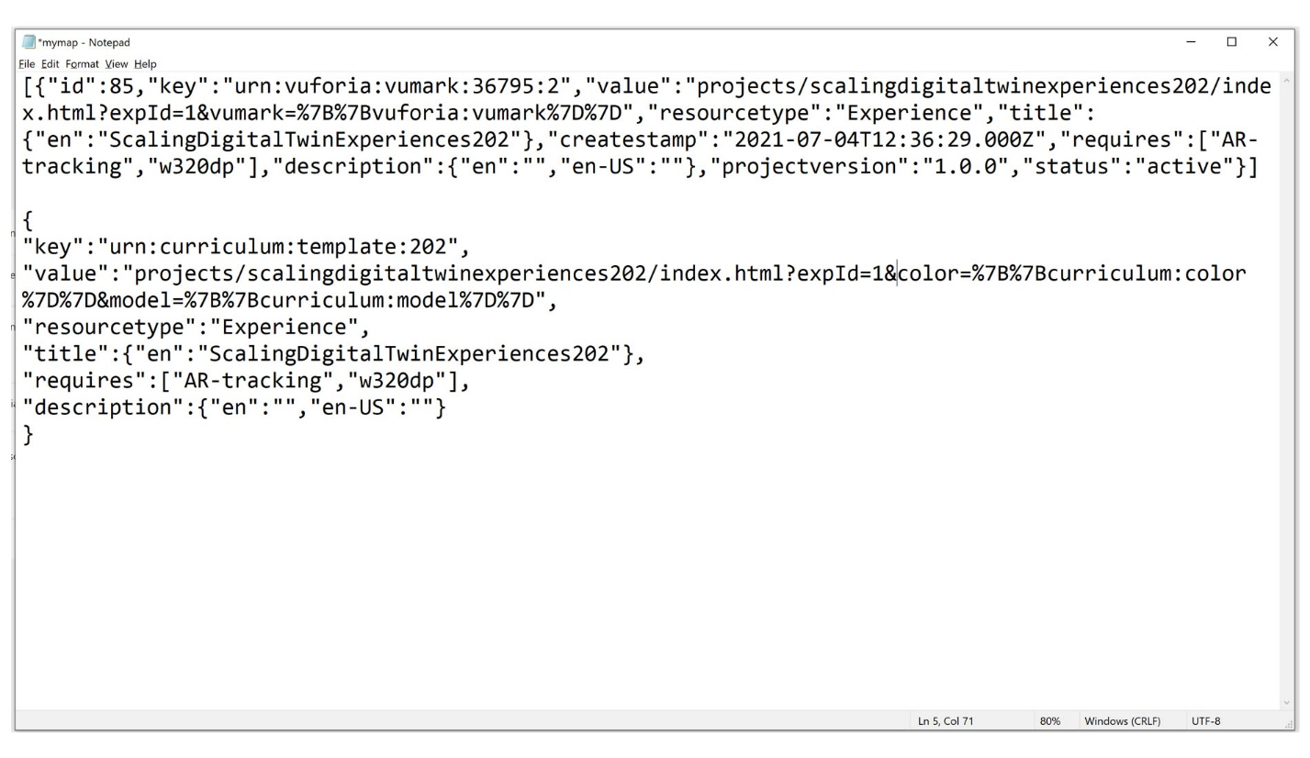

1. Finally, lets turn this bat file into a command that we will run against the IRS. First, there are some characters here that can be misinterpreted by the command interpreter, so we must ‘escape’ them to ensure the information gets through as we’d like. The amphersand (e.g &color) and the percentage (e.g. %7B) and the quotes “” are the ones we need to handle. Most editors (like notepad) have search & replace feature, so lets use that to change the characters

|  |  |
| --- | --- |
| Replace | with |
| “ | \” |
| % | %% |
| & | ^& |

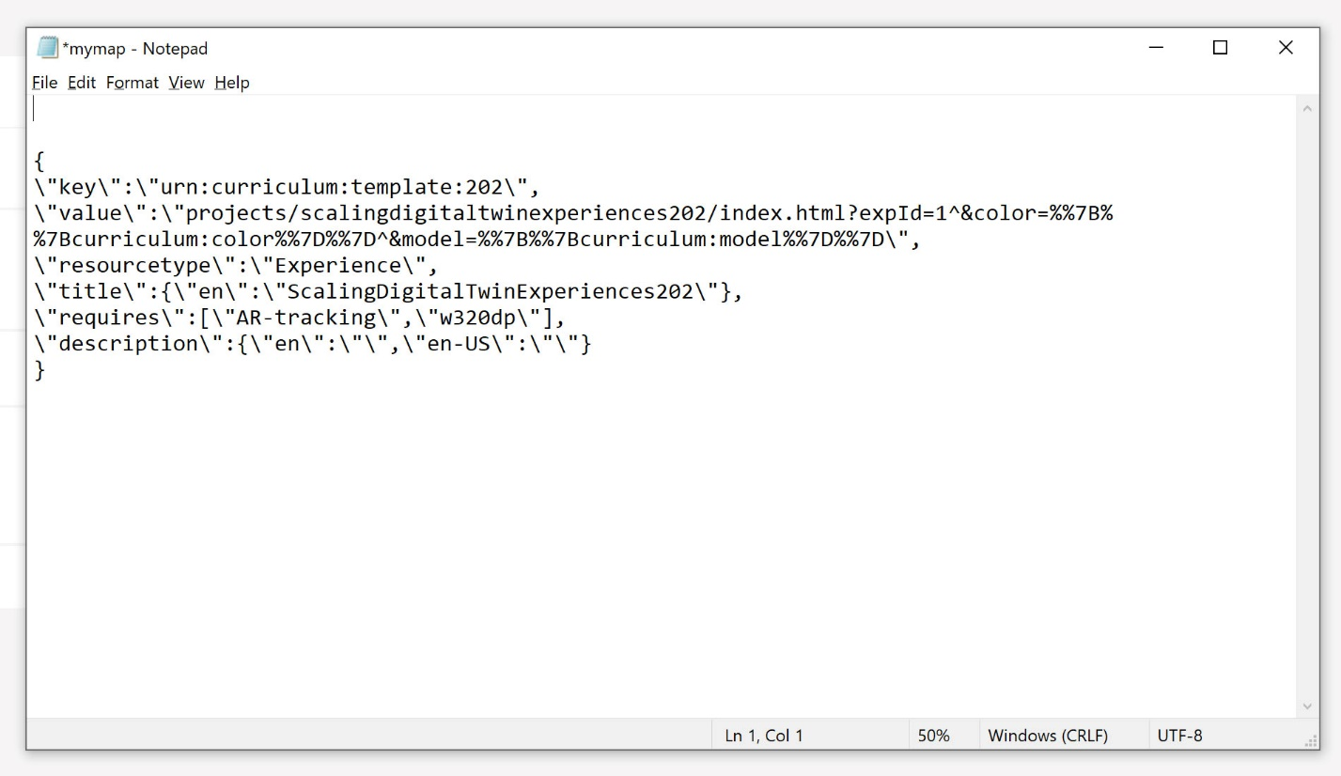

1. Add the following to the file

curl -u %uname%:%passwd% -H "Content-Type: application/json" -H "X-Requested-With: XMLHttpRequest" -k -d "EXPRIENCEGOESHERE" %server%/ExperienceService/id-resolution/mappings

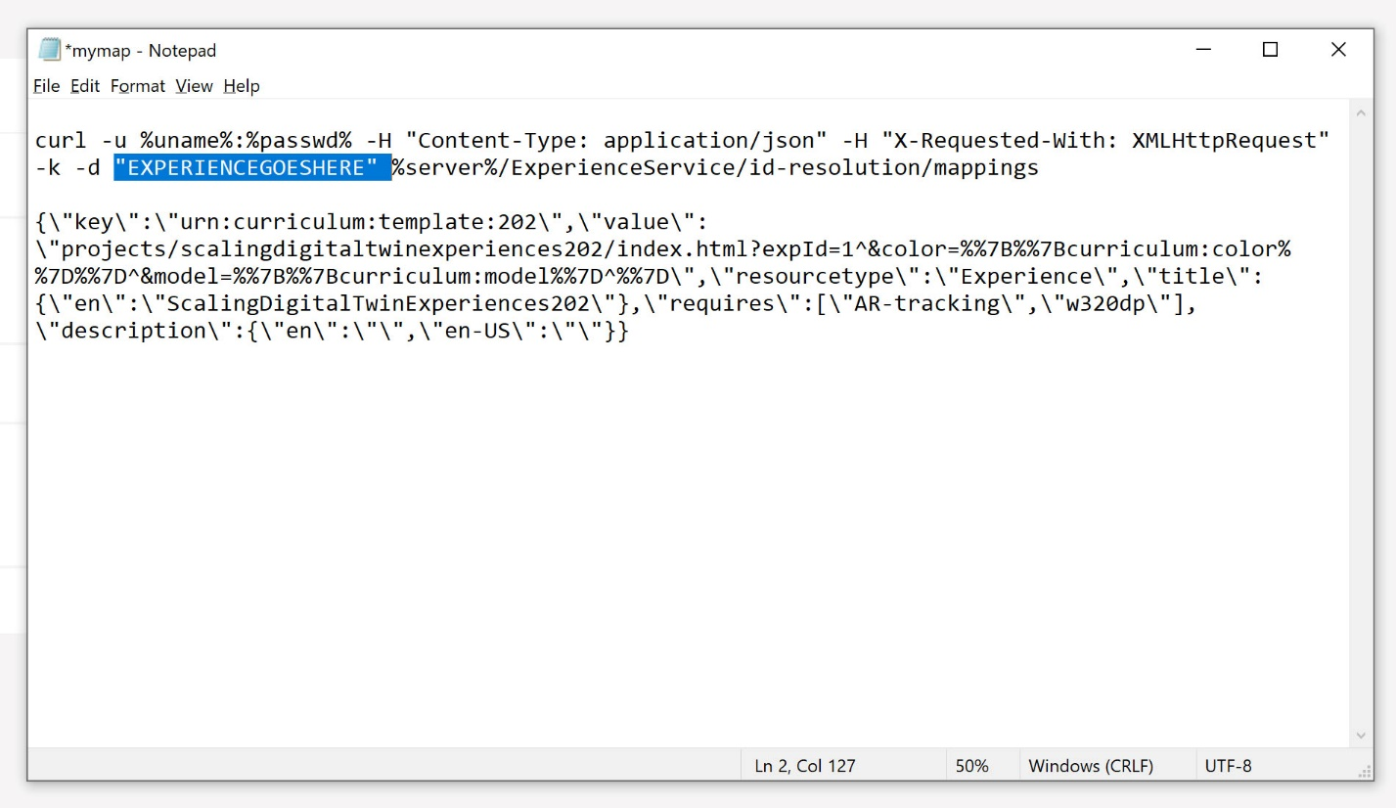

And then replace EXPERIENCEGOESHERE with the block of text you edited above.

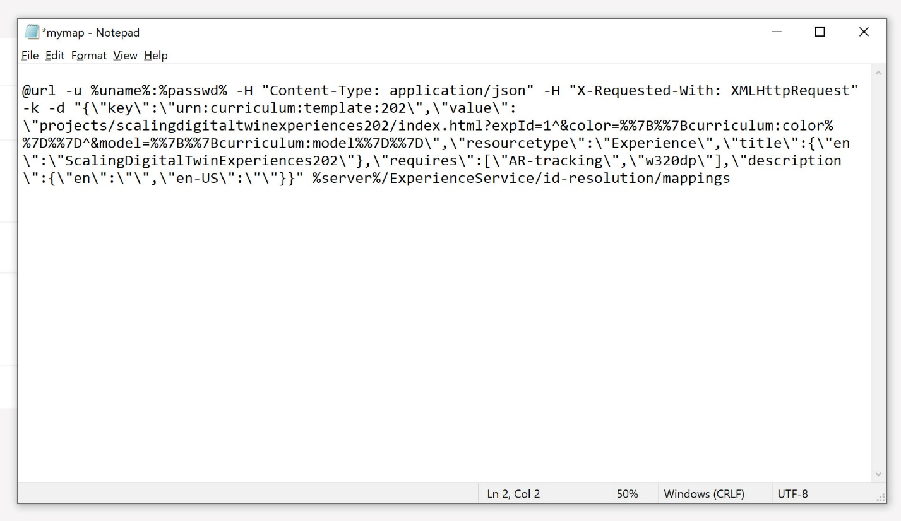

1. You can now run this batch file at the command prompt.

C:\installations> mybat.bat

1. You can also copy/paste the following

curl -u %uname%:%passwd% -H "Content-Type: application/json" -H "X-Requested-With: XMLHttpRequest" -k -d "{ \"key\":\" urn:curriculum:template:202\", \"value\":\"projects/scalingdigitaltwinexperiences202/index.html?expId=1^&color=^%7B^%7Bcurriculum:color^%7D^%7D^&model=^%7B^%7Bcurriculum:model^%7D^%7D\", \"resourcetype\":\"Experience\",\"title\" : { \"en\":\"ScalingDigitalTwinExperiences202\" }, \"requires\" : [ \"AR-tracking\",\"w320dp\" ], \"description\":{ \"en\":\"Curriculum demo\" } }" %server%/ExperienceService/id-resolution/mappings

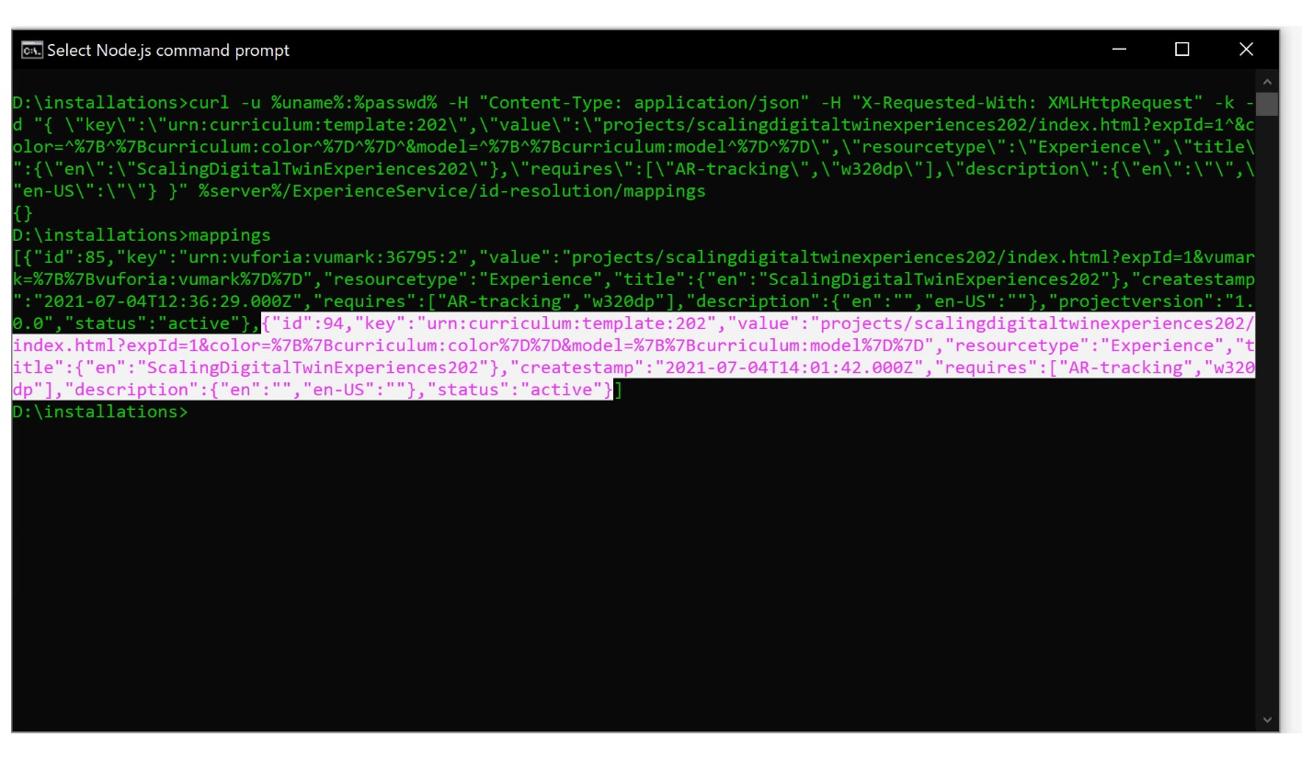

1. Run mappings to see that a new mapping has been added to the Experience Service for the template. You should see your new mapping at the end of the list of mappings.
2. Once the template is mapped to the experience, the next step is to map configurations with specific properties. These properties will be used to configure the parameters of the template that you created before for model and color. This first configuration will be named config 1.
   1. Use the code below to set your first configuration with a set color parameter. This will interact with the application parameter that you previously created in Studio, so any of the colors that you created in the first step will be available as parameter inputs. For the color, we have set the model to be purple.

curl -u %uname%:%passwd% -H "Content-Type: application/json" -H "X-Requested-With: XMLHttpRequest" -k -d "{\"key\": \"urn:curriculum:config:1\", \"value\": \"urn:curriculum:color:purple\"}" %server%/ExperienceService/id-resolution/mappings

* 1. You will also map the model parameter the same way that you mapped the color parameter. This time, you will be using 2 as the model parameter, which maps to the second quadcopter model option. With them being mapped, the key urn:curriculum:config:1 will now map to both values of urn:curriculum:color:purple and urn:curriculum:model:2.

curl -u %uname%:%passwd% -H "Content-Type: application/json" -H "X-Requested-With: XMLHttpRequest" -k -d "{\"key\": \"urn:curriculum:config:1\", \"value\": \"urn:curriculum:model:2\"}" %server%/ExperienceService/id-resolution/mappings

* 1. If you run mappings again, you will see that the configuration mappings have been added to the IRS.

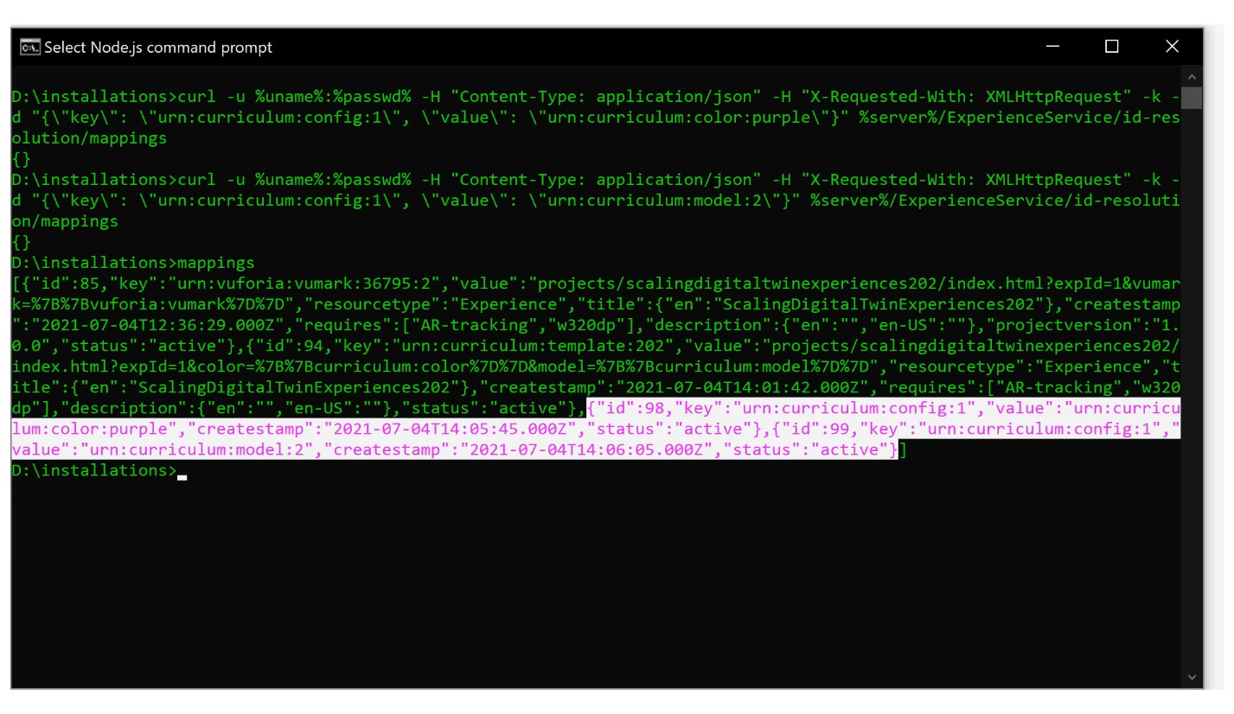

1. Once the configuration and its parameters are created, the configuration needs to be mapped back to the template. Previously we mapped urn:curriculum:template:202 to the experience as its template, now urn:curriculum:config:1 will be mapped back to urn:curriculum:template:202

curl -u %uname%:%passwd% -H "Content-Type: application/json" -H "X-Requested-With: XMLHttpRequest" -k -d "{\"key\": \"urn:curriculum:config:1\", \"value\": \" urn:curriculum:template:202\"}" %server%/ExperienceService/id-resolution/mappings

1. The last step for mapping these configurations is to map your ThingMark to the configuration that you created. Whenever you scan this specific ThingMark, this specific configuration of the model will appear. **Note**: you will have to input your specific ThingMark instance where prompted.

curl -u %uname%:%passwd% -H "Content-Type: application/json" -H "X-Requested-With: XMLHttpRequest" -k -d "{\"key\": \"urn:vuforia:vumark:**YOURTHINGMARK**\", \"value\": \"urn:curriculum:config:1\"}" %server%/ExperienceService/id-resolution/mappings

1. Run mappings once again. You should now see all the mappings that you’ve created throughout this tutorial listed.

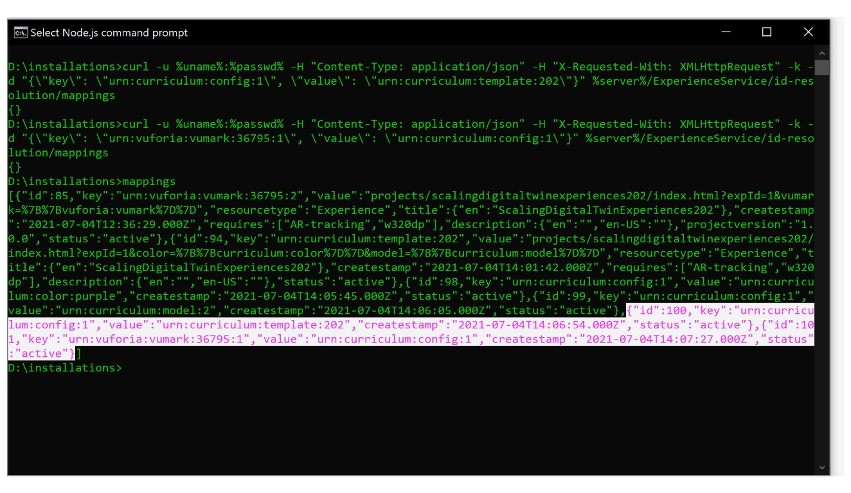

1. To connect everything you’ve learned, the mappings that you’ve created in this tutorial are:
   1. urn:vuforia:vumark:**YOURTHINGMARK** => urn:curriculum:config:1
   2. urn:curriculum:config:1 => urn:curriculum:color:purple
   3. urn:curriculum:config:1 => urn:curriculum:model:2
   4. urn:curriculum:config:1 => urn:curriculum:template:202
   5. urn:curriculum:template:202 => your experience
2. Check your work by running resolve urn:vuforia:vumark:**YOURTHINGMARK** in the CLI. This is taking all the resolutions assigned to that ThingMark and putting them into text form. If you see color=purple&model=2 instead of color=^%7B^%7Bcurriculum:color^%7D^%7D^&model=^%7B^%7Bcurriculum:model^%7D^%7D, then this mapping has been added successfully. The model parameters replaced the placeholder variables that were originally in the URL.

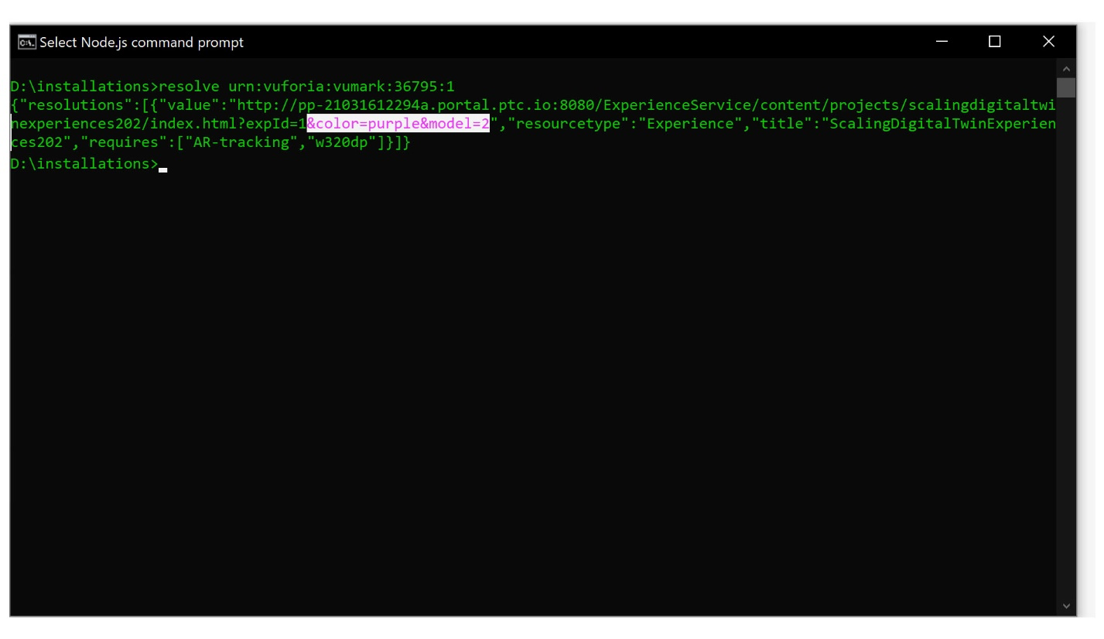

1. Open Vuforia View and scan the ThingMark that you assigned urn:curriculum:config:1 to. If you see the configuration of the quadcopter that you created appear, you have successfully added your first configuration using the IRS.

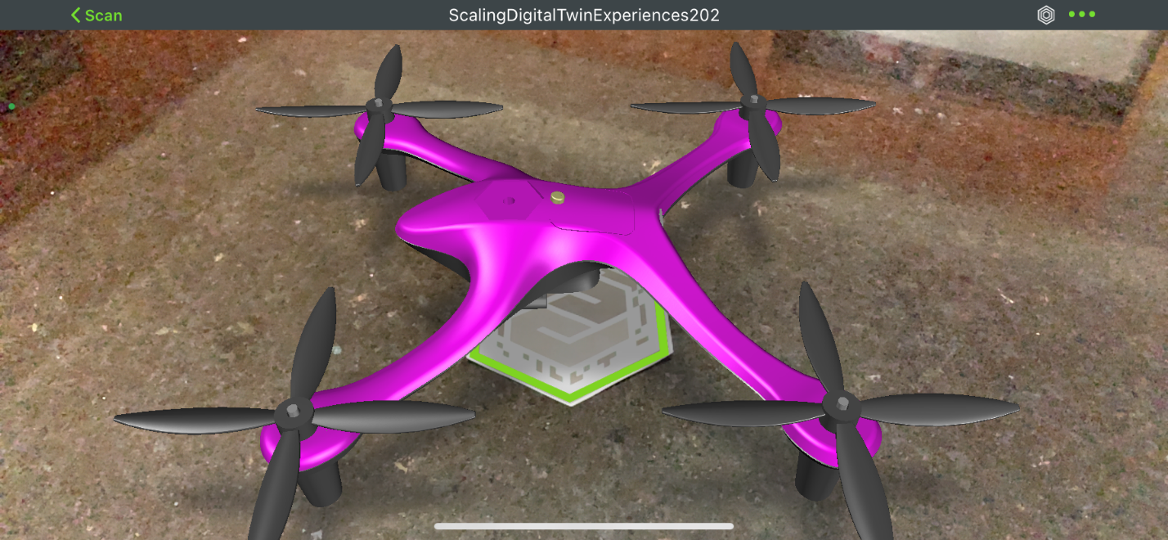

1. Now that you’ve successfully created one configuration, try on your own to create two more configurations named config:2 and config:3 using the curriculum template that you created. Configurations can be added to either the same ThingMark or a different one. You should create the new mappings:

urn:vuforia:vumark:**YOURTHINGMARK** => urn:curriculum:config:2

urn:curriculum:config:2 => urn:curriculum:color:NEWCOLOR

urn:curriculum:config:2 => urn:curriculum:model:PICKAMODEL

urn:curriculum:config:2 => urn:curriculum:template:202

urn:vuforia:vumark:**YOURTHINGMARK** => urn:curriculum:config:3

urn:curriculum:config:3 => urn:curriculum:color:NEWCOLOR

urn:curriculum:config:3 => urn:curriculum:model:PICKAMODEL

urn:curriculum:config:3 => urn:curriculum:template:202

1. Use Vuforia View again to see your newly created configurations appear.

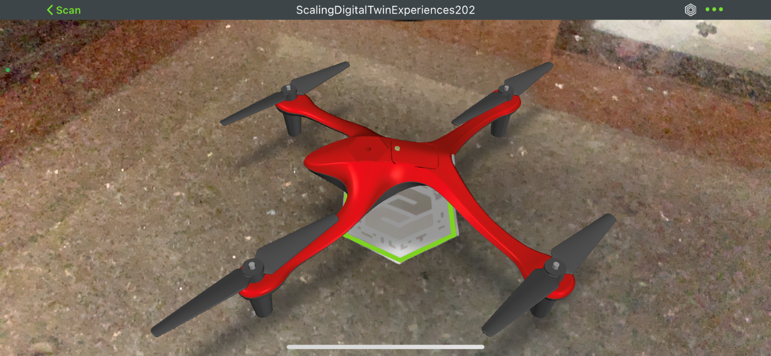

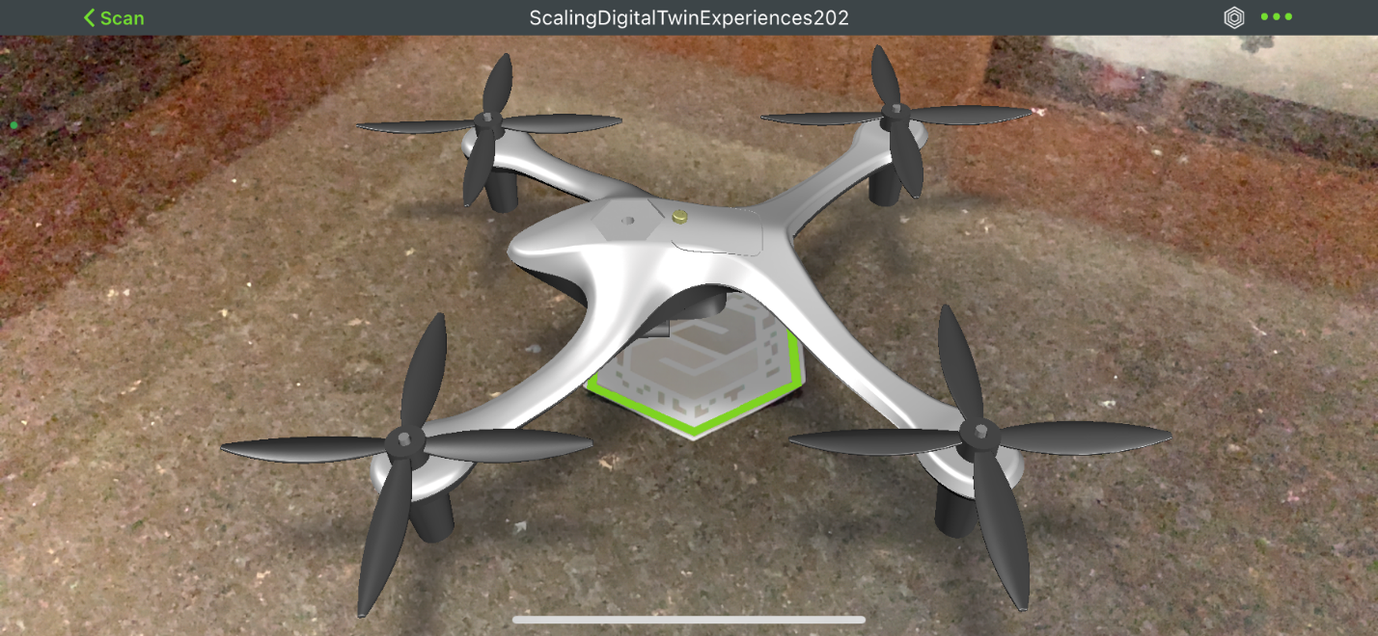

1. A semi-completed batch file that can be run to execute all the mappings in steps 11-17 for three different configurations named [ScalingDigitalTwinExperiences202.bat](https://github.com/PTCInc/StudioExamples/blob/master/Scaling%20Digital%20Twin%20Experiences/Scaling%20Digital%20Twin%20Experiences%20200/ScalingDigitalTwinExperiences202.bat) is included in GitHub, along with the mappings.bat and resolve.bat files. You will need to add your username, password, server, vumark numbers, and edit the project name (if applicable) before the file can be run. Run the file by typing ScalingDigtialTwinExperiences202 into the CLI while in the directory where you have saved your other files.

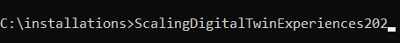

The final result is 3 configurations. A thingmark (1) maps to the configuration, which (2) gathers various properties/values on the pathway to the template (3) which replaces variables (color, model) with the values collected. The result is an experience with the variable inputs resolved – in this example, the thingmark maps to configuration 2, which is a red model1 item. The final experience shows a red quadcopter.

